**Name: Dhruv BArot**

**Student Id: 101415874**

**Course code: Comp3133**

**Lab Exercise 04**

**Screenshots**

**Screenshot 01:**

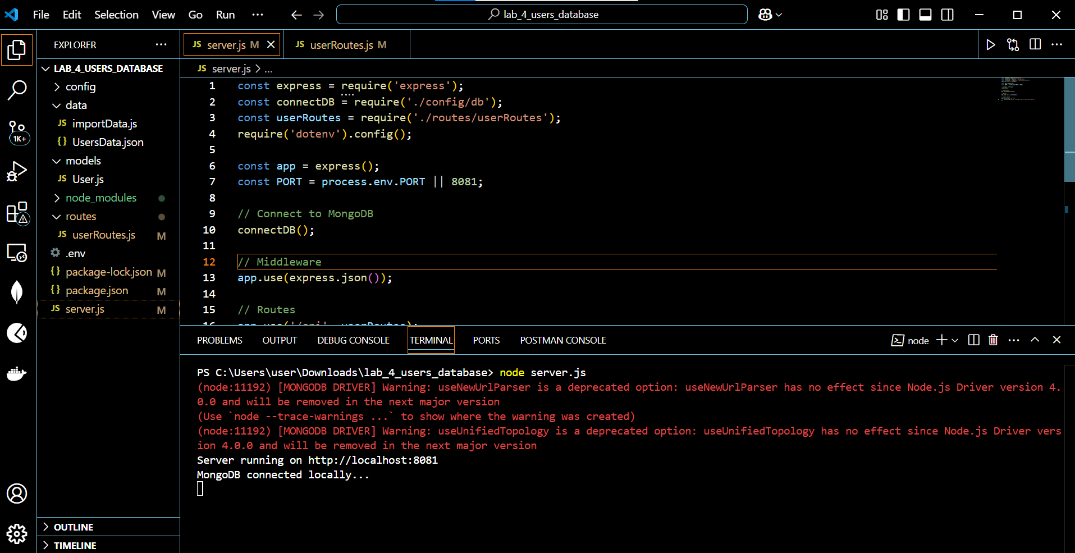

**Screenshot 02:**

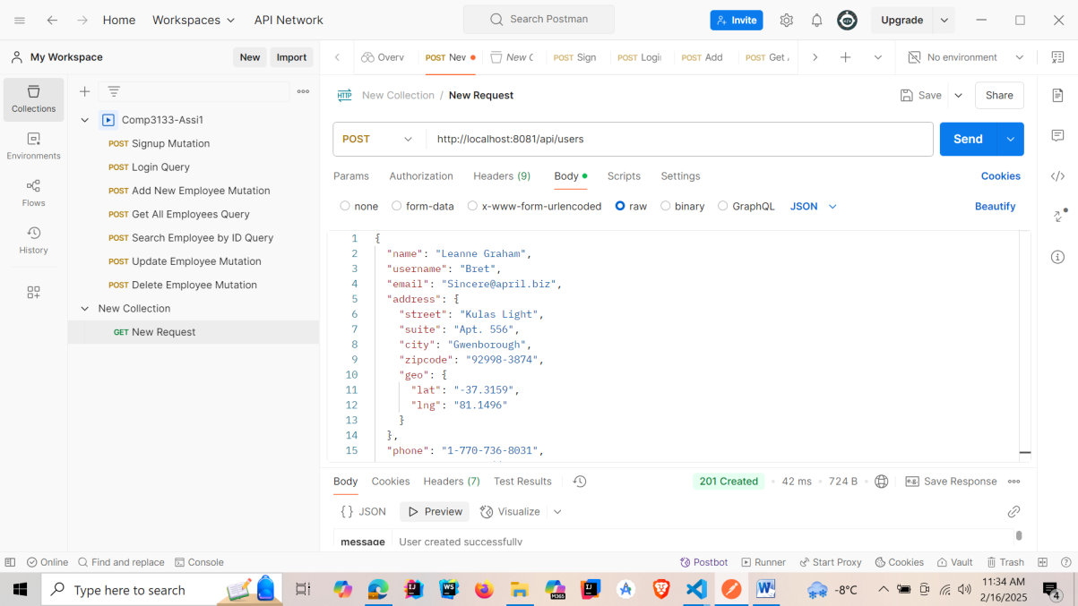

**Screenshot 03:**

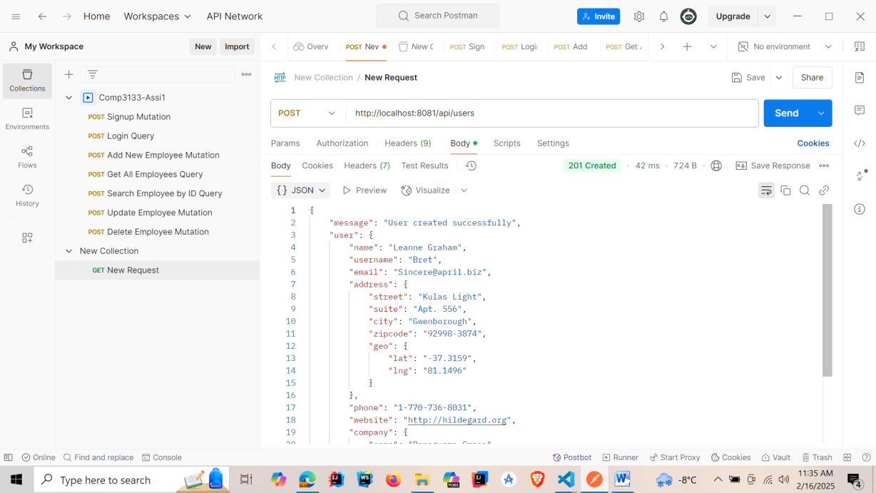

**Screenshot 04:**

